**TERM2 PRACTICALS**

1.#program for list functions to add and remove elements from list

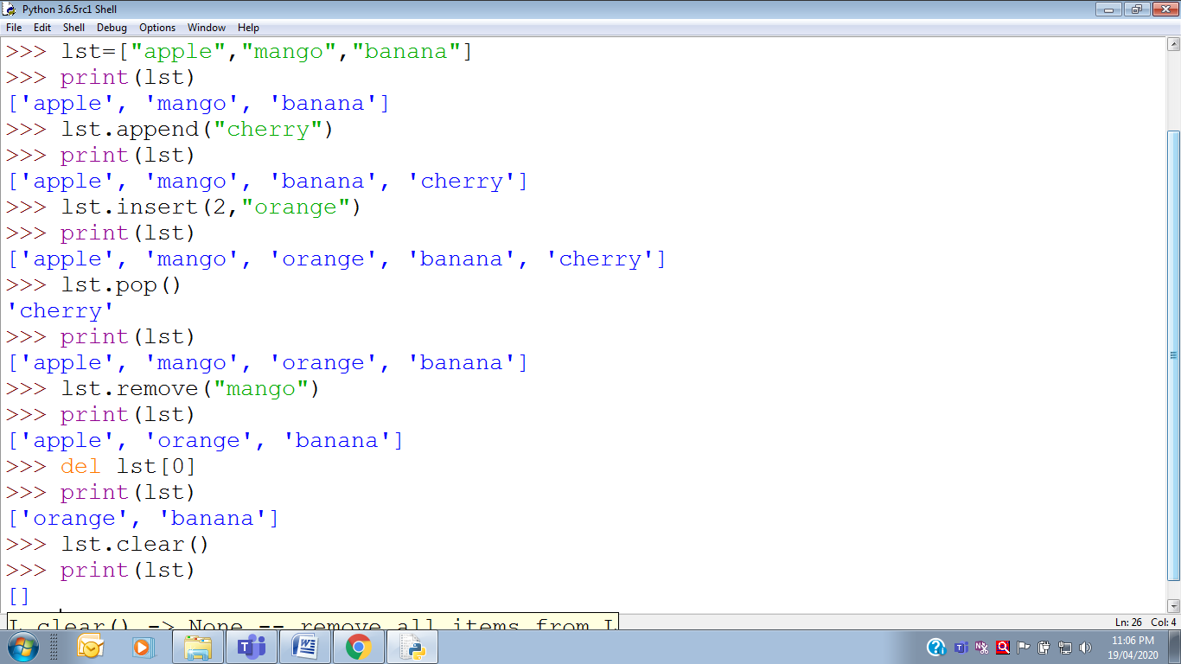

2.

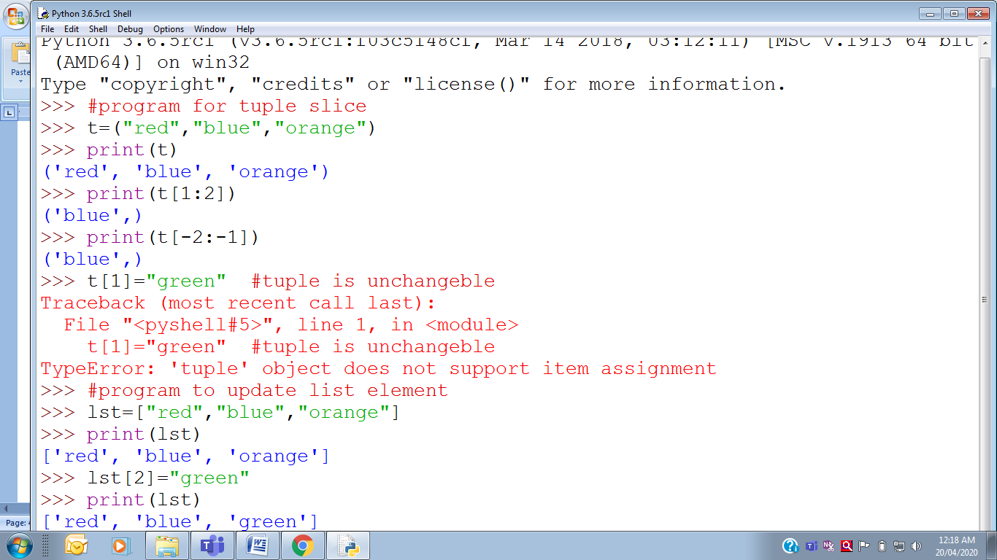 

3.

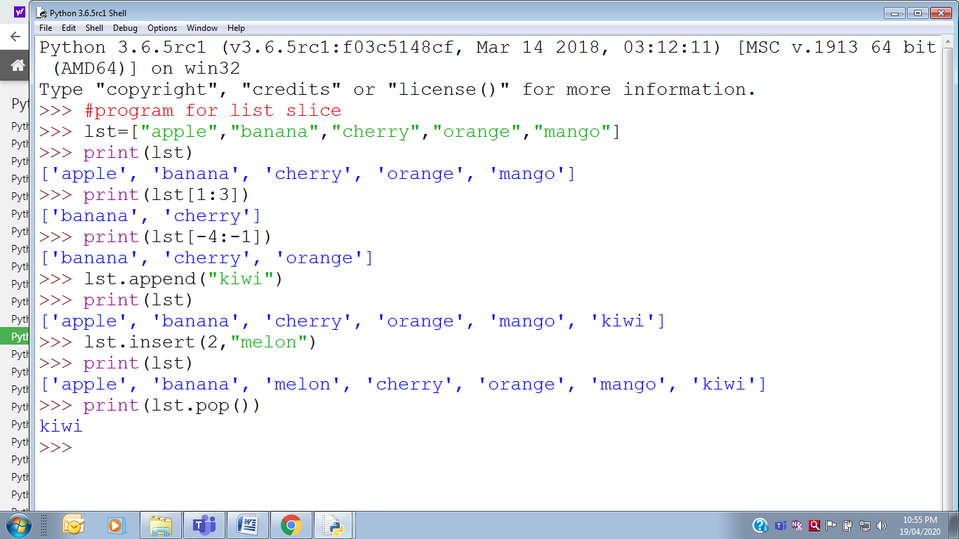

4.**#program to sort and then reverse list**

list=[5,1,7,3]

print(list)

**output: [5,1,7,3]**

print(list.sort())

**output: [1,3,5,7]**

print(list.reverse())

**output:[7,5,3,1]**

5**.#program to count occurrence of element “red” in list**

list=[‘red’,’blue’,’green’,’red’,’yellow’]

print(list)

**output: =[‘red’,’blue’,’green’,’red’,’yellow’]**

print(list.count(‘red’)

**output: 2**

6.#program to copy list in to another

list1=[1,2,3,4,5]

print(list)

**output: [1,2,3,4,5]**

list2=list1[1:4].copy()

print(list2)

**output: [2,3,4]**

7. program for nested list in python

#Nested list: One list nested inside another list in python

list=[[1,2],[3,4],[5,6]]

print(list)

**output: [[1,2],[3,4],[5,6]]**

print(list[0])

**output: [1,2]**

print(list[1])

**output: [3,4]**

print(list[2])

**output: [5,6]**

8.#program to extend list

m=[1,2]

n=[3]

print(n.extend(m))

**output: [3,1,2]**

9.#program to find total no of elements in list and return index number of element

p=[10,20,30,40]

print(len(p))

**output: 4**

p.index(2)

**output: 30**

10.

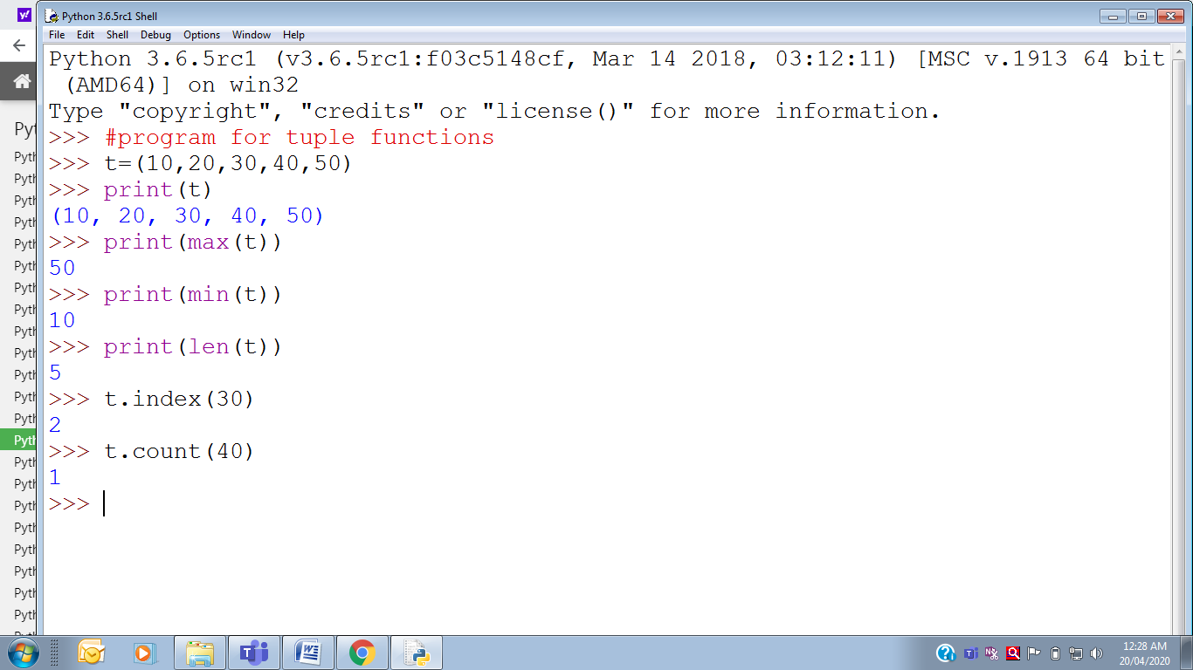

11.program to find to find index number of minimum and maximum element in a tuple.

>>> t=(5,7,3,9)

>>> minimum=min(t)

>>> maximum=max(t)

>>> print("tuple is",t)

**tuple is (5, 7, 3, 9)**

>>> print("minimum element is",minimum,"its index is",t.index(minimum))

**minimum element is 3 its index is 2**

>>> print("maximum element is",maximum,"its index is",t.index(maximum))

**maximum element is 9 its index is 3**

12.program to input an unsorted tuple and return new sorted list with sorted elements in it.

>>> t1=eval(input ("enter unsorted elements for tuple"))

**enter unsorted elements for tuple 8,9,3,4,2**

>>> t2=sorted(t1)

>>> print("orignal tuple unsorted",t1)

**orignal tuple unsorted (8, 9, 3, 4, 2)**

>>> print("New sorted tuple",t2)

**New sorted tuple [2, 3, 4, 8, 9]**

13.program to input a tuple from user. Find length of tuple and calculate sum.

>>> t=eval(input("enter elements"))

**enter elements5,1,3,7,6**

>>> print("no of elements in tuple is",len(t))`

**no of elements in tuple is 5**

>>> print("tuple is",t)

**tuple is (5, 1, 3, 7, 6)**

>>> print("sum of tuple is",sum(t))

**sum of tuple is 22**

14. program for tuple operators.

>>> t=(1,2,3)

>>> print(t*3)

**(1, 2, 3, 1, 2, 3, 1, 2, 3)**

>>> t1=(5,4,3)

>>> t2=(6,7)

>>> print(t1+t2)

**(5, 4, 3, 6, 7)**

>>> 4 in t1

**True**

15.#program to add delete elements in a dictionary

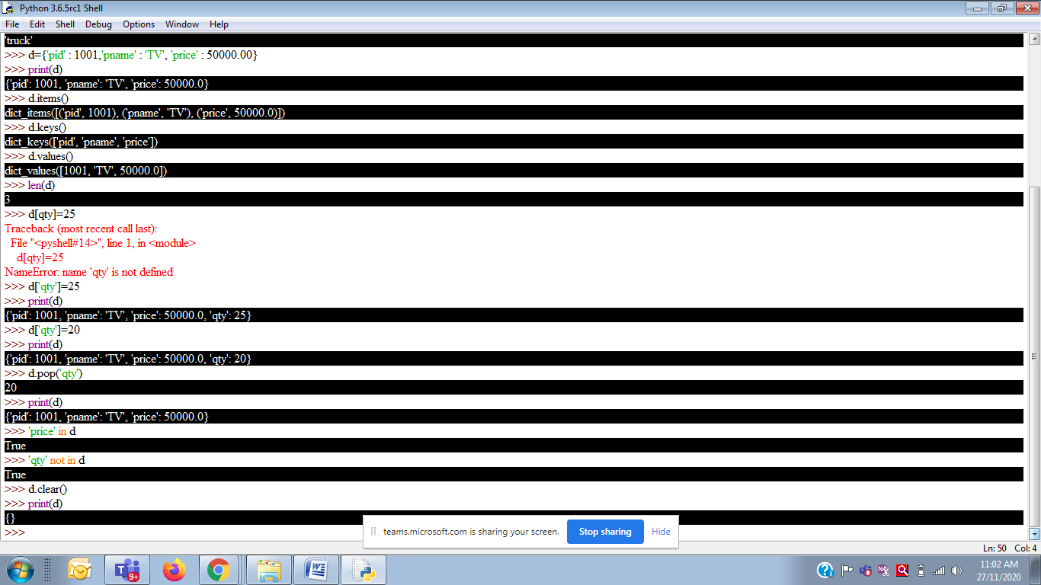



17.# **program to create a dictionary dict which stores marks of a students of class with rollno as keys and marks as values. Get the number of students as input.**

dict={ }

n=int(input("Enter no of student"))

for i in range(n):

r,m=eval(input("enter rollno, marks"))

dict[r]=m

print("created dictionary")

print(dict)

ch=input("want to modify marks y/n")

if ch=='n':

exit

else:

r=int(input("rollno to modify marks"))

if r in dict:

dict[r]=int(input("enter new marks"))

print(dict)

else:

exit

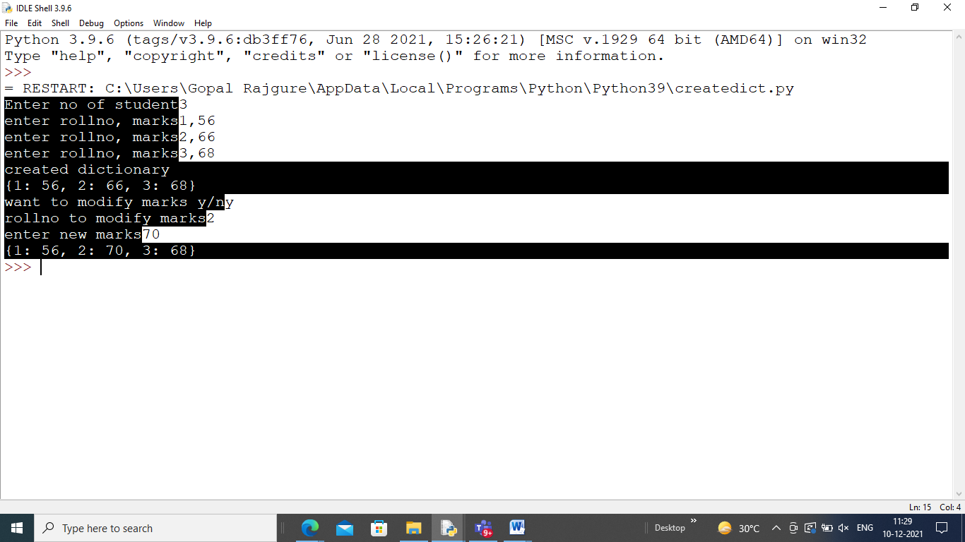

18.**#School has decided to deposit scholarship amount of rs2500 to some selected students. Write program to input selected roll numbers and create a dictionary for the same.**

L= [ ]

n=int(input("enter no of students"))

for i in range(n):

r=int(input("enter rollno:"))

L.append(r)

s=dict.fromkeys(L,2500)

print("created dictionary")

print(s)

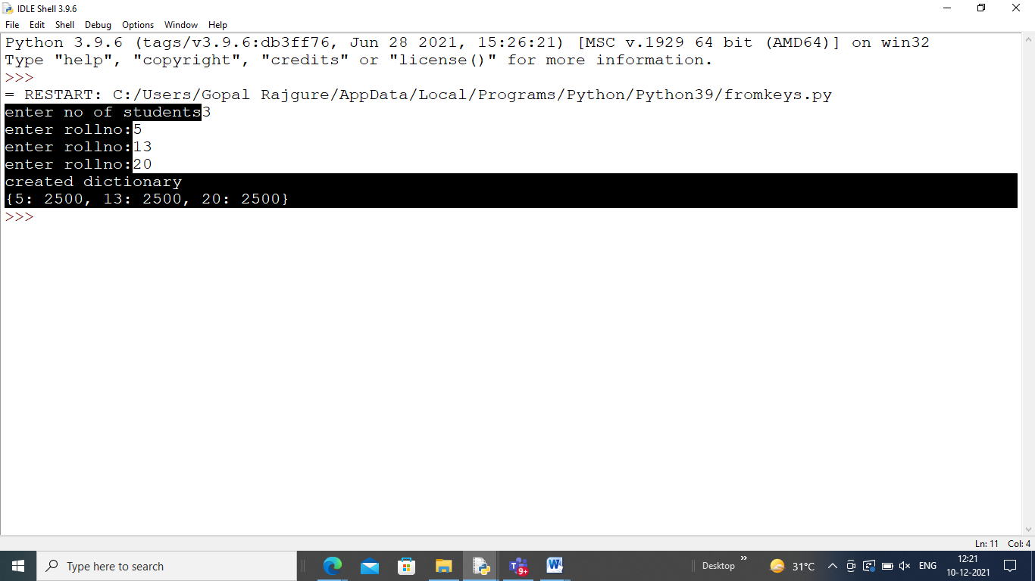

**PROJECT ON HANGMAN GAME**

**INTRODUCTION**

Hangman is an online Kids game, it's playable on all smartphones or tablets, such as iPhone, iPad, Samsung and other Apple and android system. In the interesting word guessing game Hangman, players need to find out the corresponding letters to form a word according to the prompts.

**PROJECT SOURCE CODE**

import random

wordlist= ["planet","tree","random","free","holiday","notebook","school","simple","coding"]

word_chosen = ""

word_visualization = ""

max_guesses = 10 wordlist

current_guesses_counter = 0

letters_guessed = []

current_guess = ""

while True:

word_chosen = random.choice(wordlist)

letters_guessed = len(word_chosen) * "_"

current_guesses = 0

print("Welcome to hangman!")

print("You need to guess what word I am thinking of.")

print("This word is ", len(letters_guessed), " letters")

while current_guesses_counter < max_guesses:

current_guess = input("Enter a letter: ")

for i in range(0, len(word_chosen)):

if word_chosen[i] == current_guess:

letters_guessed = letters_guessed[:i] + current_guess + letters_guessed[i+1:]

print("You got a letter!")

print(letters_guessed)

if word_chosen == letters_guessed:

print("You won this time!")

exit()

current_guesses_counter+=1

print("I got you this time, the word was:", word_chosen)

exit()

**PROJECT OUTPUT**

